BCSE309L & Cryptography and Network Security – Winter 2024-25
Answer Key (E1 Slot)

Q. No | Question | M | CO | BL
1. | a) Find 15^276 mod 97 using the method of fast modular exponentiation. Also, determine the result step-by-step and explain how the exponentiation and modular operations are applied iteratively.  Answer:  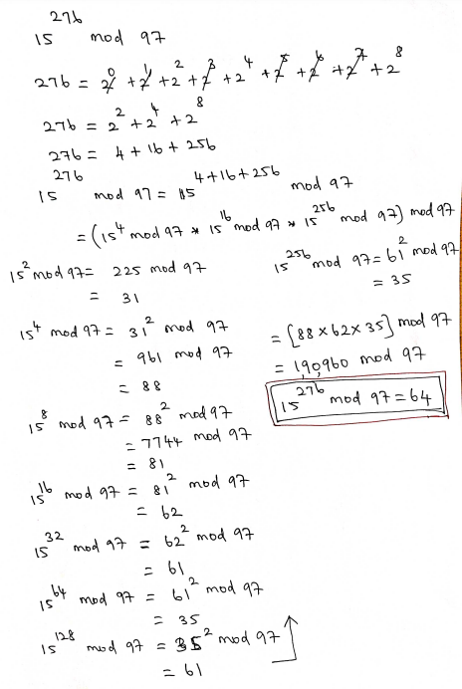 | 7
 | b) Compute ϕ (8820) using the property of Euler’s Totient Function. Describe your steps clearly.  Answer:  Property formulae: 1 mark  Detailed steps and correct answer: 2 marks  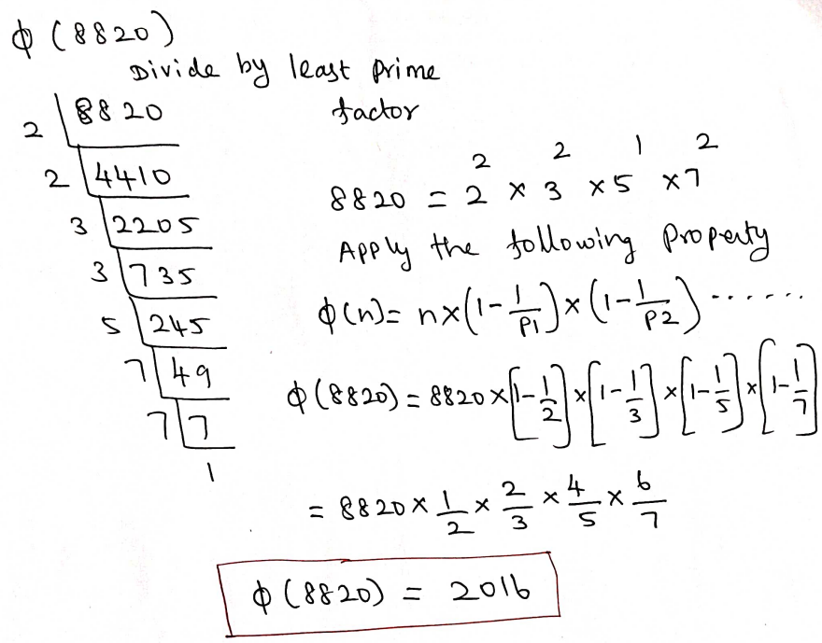 | 3
2. | a) Solve the following congruent equations and find the X value using Chinese Remainder Theorem.  X ≡ 5 (mod 18)  X ≡ 3 (mod 11)  X ≡ 0 (mod 5)  Answer:  Relatively prime check, M, M1, M2 & M3 – 3 marks  M1, M2, M3 Inverse values, X value – 4 marks  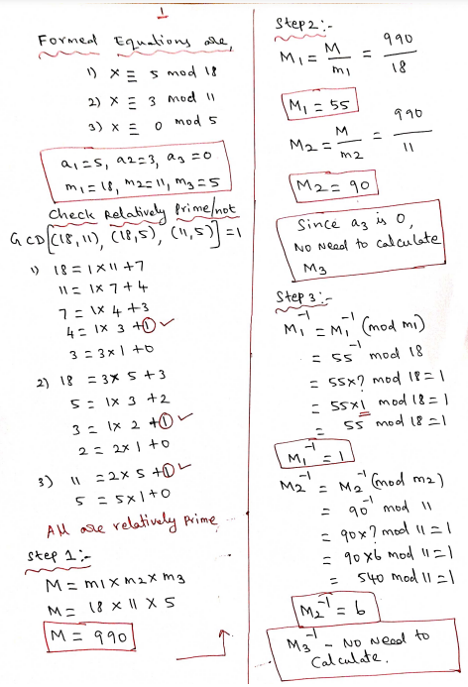  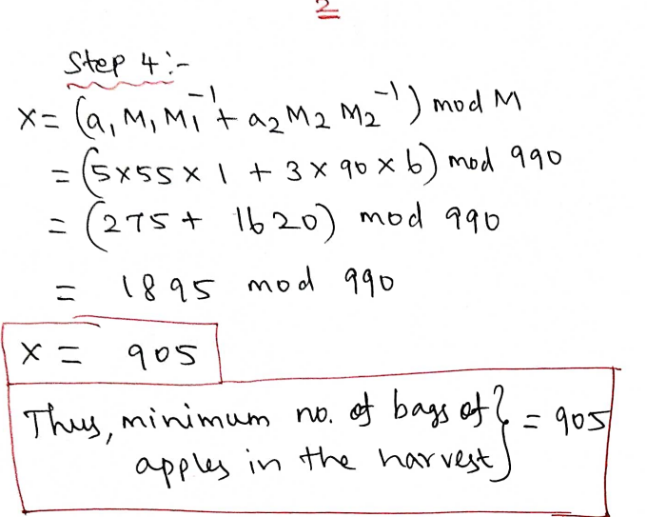 | 7
 | b) Write the algorithm steps of Miller-Robin algorithm.  Answer:  The below answer is one of the algorithm’s steps. Some other alternate algorithm steps also there. You can follow any algorithm.   | 3
3. | Explain in detail the state and key initialization, initial state permutation, key stream generation and encryption process of RC4 algorithm with diagram and algorithm steps.  Answer:  state and key initialization (Diagram + Algorithm steps + Explanation) – 2.5 marks  initial state permutation (Diagram + Algorithm steps + Explanation) – 2.5 marks  key stream generation (Diagram + Algorithm steps + Explanation) – 2.5 marks  encryption process (Diagram + Algorithm steps + Explanation) – 2.5 marks  Diagram:  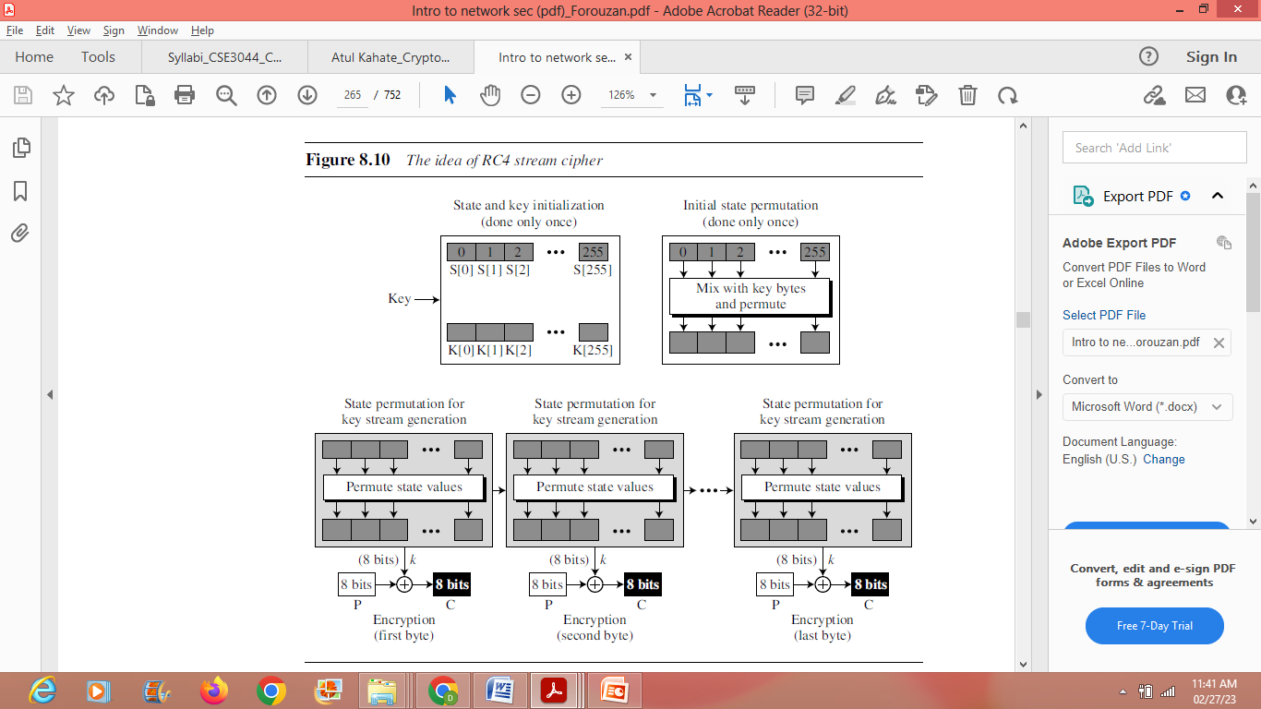  Algorithm steps:  state and key initialization:  - for (i = 0 to 255)  - {  - S[i] ← i  - K[i] ← Key [i mod KeyLength]  - }  Initial state permutation:  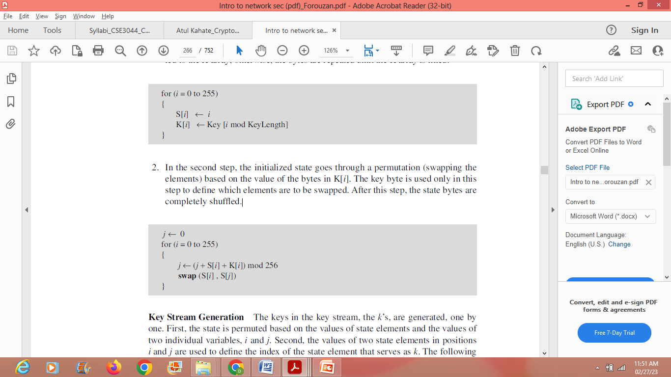  key stream generation:  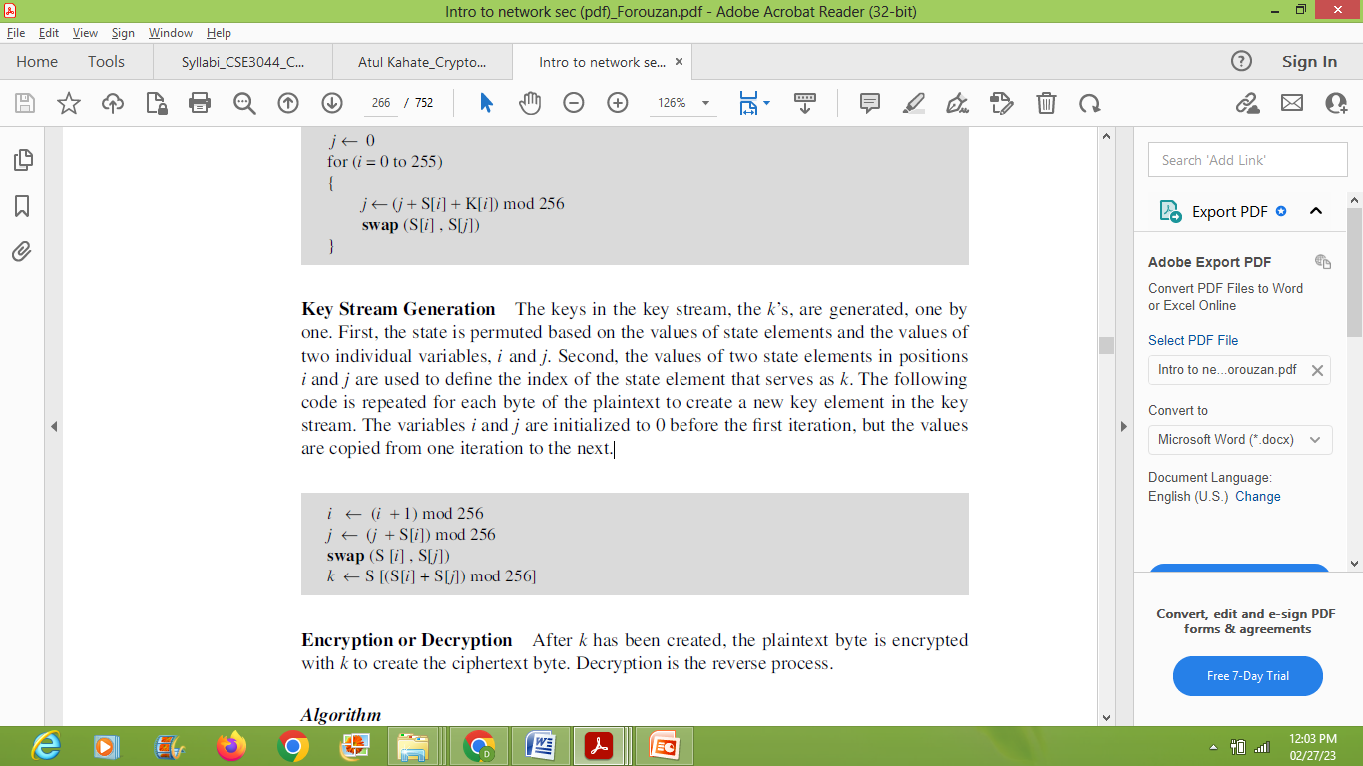  Encryption process:  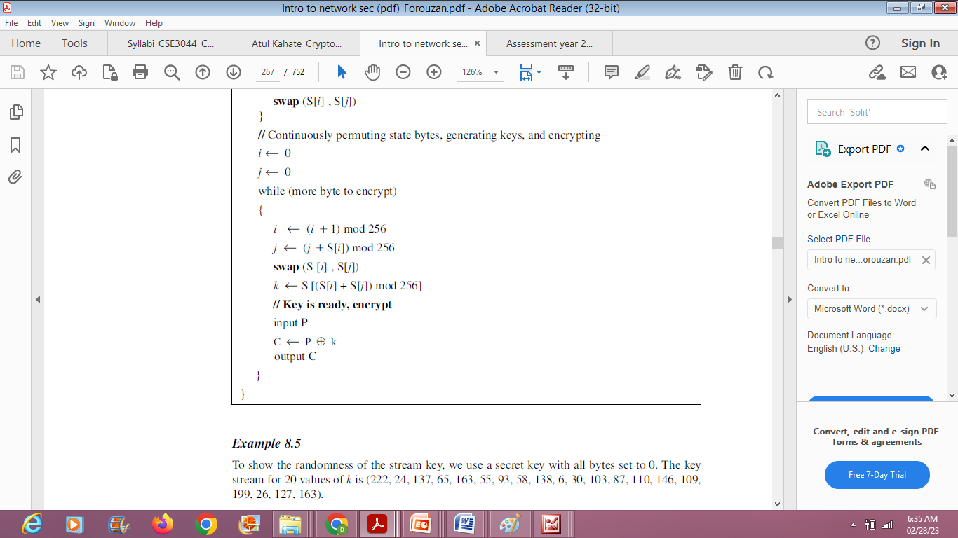 | 10
4. | Construct the shift row matrix from the given sub byte matrix (given in Hex) in AES algorithm. Also, find X and Y values in the given output of mix column matrix using the given fixed matrix and determined shift row matrix (Hint: when finding X & Y values, consider fixed matrix as first matrix and shift row matrix as second matrix)  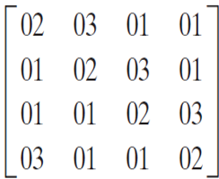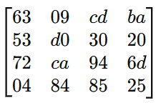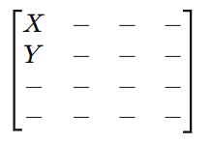  Fixed matrix Sub byte matrix Mix column matrix  Answer:  Output of Shift Row: 2 marks  Finding X value in the output of Mix column: 4 marks  Finding Y value in the output of Mix column: 4 marks  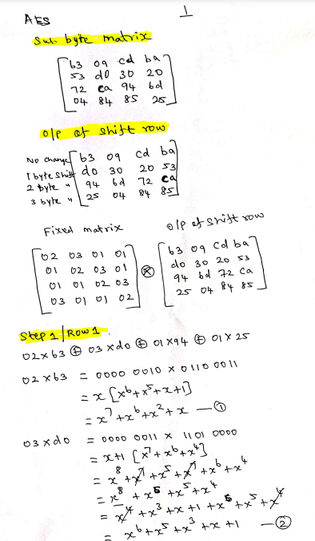  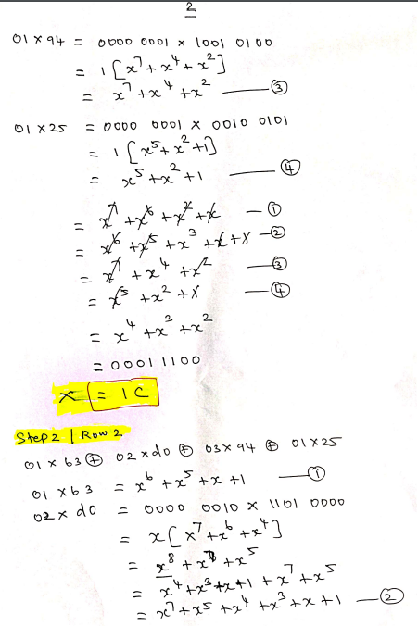  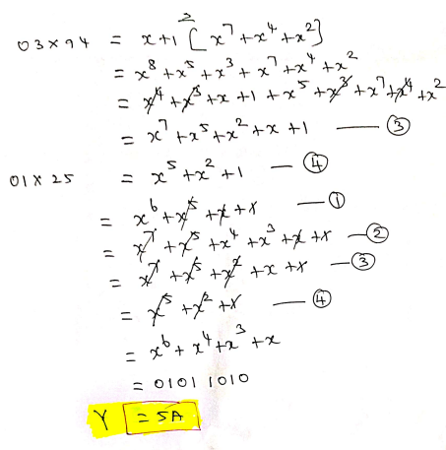 | 10
5. | Describe the operation of S-Box group and S-Box rule. Also, Find the output of S box group from the output of the whitener (XOR) operation of DES function using given S-Box tables. The output of the whitener is 48-bit values, which serves as the input to the S-boxes. The 48-bit values are given as follows:  110011101010011001110110000011111000101011011110  Answer:  Operation of S-box group: 1 mark  S-Box Rule: 1 mark  Output of the S box group (Each s-box:1 mark): 8 marks  Operation of S-box group:  (Either draw this diagram or theoretically, they can explain)  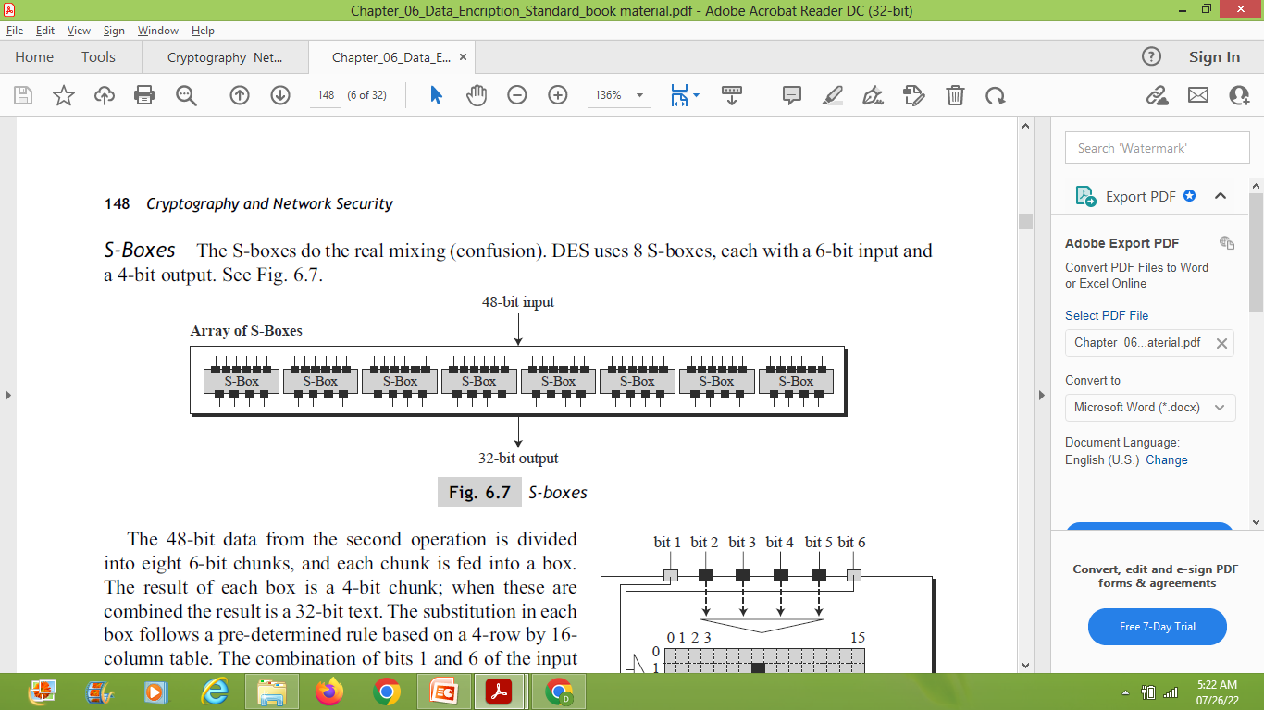  S-Box Rule:  (Either draw this diagram or theoretically, they can explain)  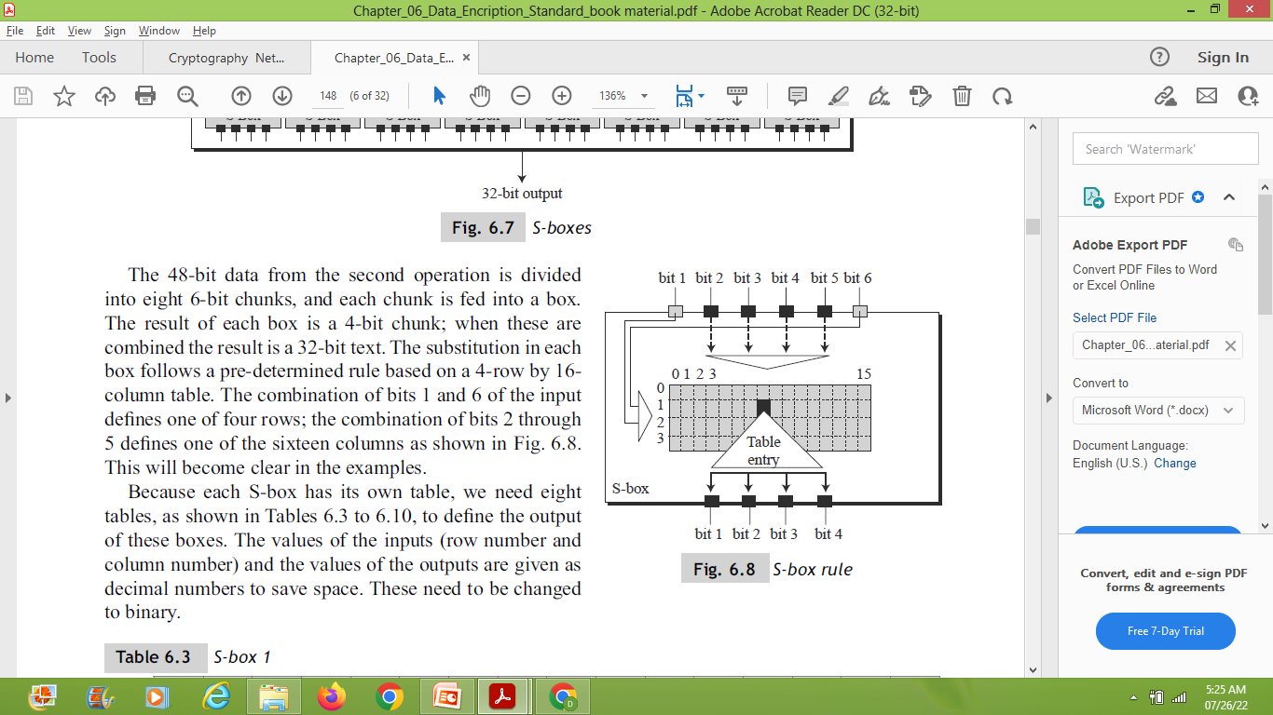  Output of the S-Box Group:  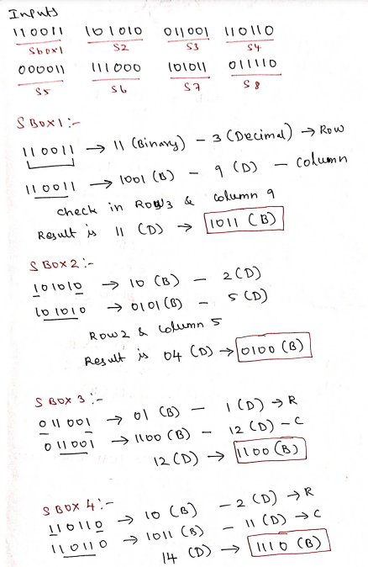  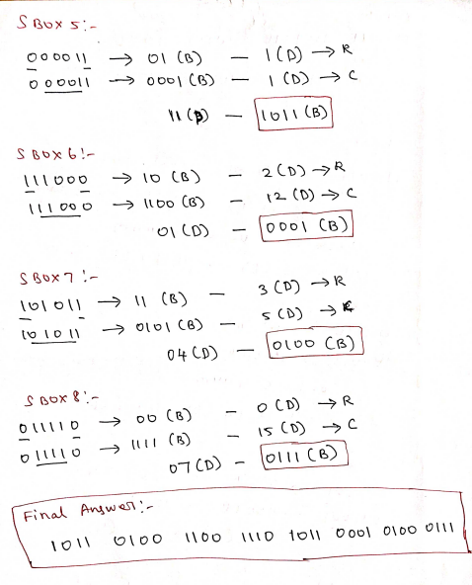 | 10

**********************

